St Joseph’s Catholic Primary School |  |  |  | Knowledge Organiser |  | 
Foundation in Art  EYFS |  | Autumn  Drawing: Marvellous Marks
Lesson 1  Mark making with wax crayons  To investigate the marks and patterns made by different textures | Lesson 2  Mark making with felt tips  To explore making marks with felt tips |  | Lesson 3  Mark making with chalk  To explore mark making with chalk | Lesson 4  Observational drawings with pencil  To explore mark making using pencils | Lesson 5  Drawing faces  To create simple observational drawings | Lesson 6  Drawing faces in colour  To use a variety of colours and materials to create a self-portrait.
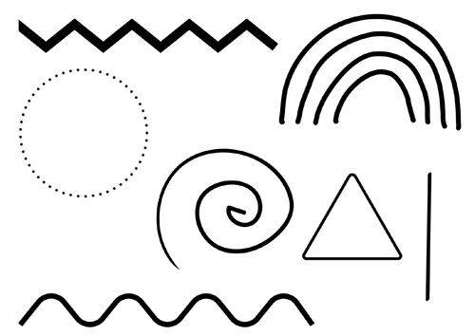
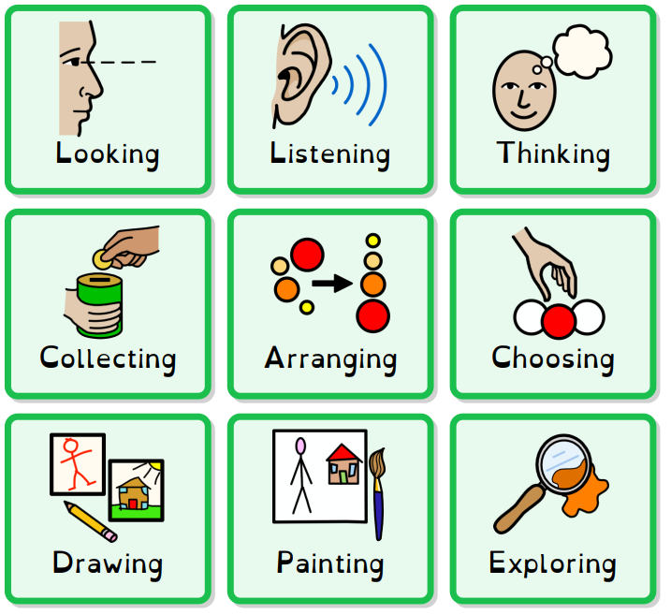
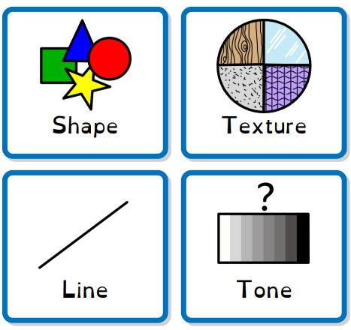
Key words Art is… Mark making could look like…

