St Joseph’s Catholic Primary School |  |  |  | Knowledge Organiser |  | 
Foundation in Art  Year 1 |  | Autumn  Drawing: Exploring line and shape
Lesson 1  Exploring Line  To explore control and pressure to create different types of lines. | Lesson 2  Musical Lines  To practice drawing different lines using music as a stimulus. |  | Lesson 3  Exploring shape  To connect lines to create shapes. | Lesson 4  Shape in art  To explore lines and shapes in pictures for portrait drawing. | Lesson 5  Klee portraits  I can design and create images and models from my own idea | Lesson 6  Every picture tells a story  To create an artist-inspired artwork using lines and shapes.
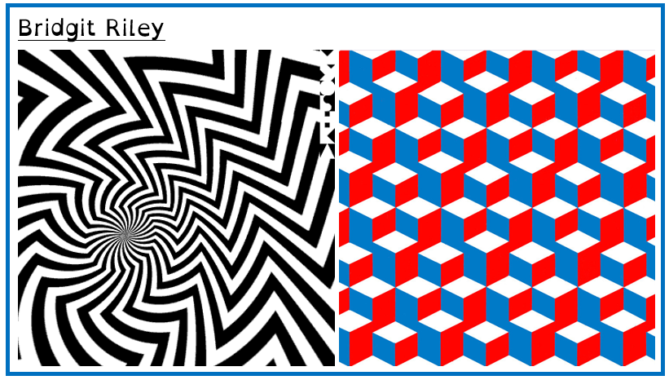
Mark making Artists
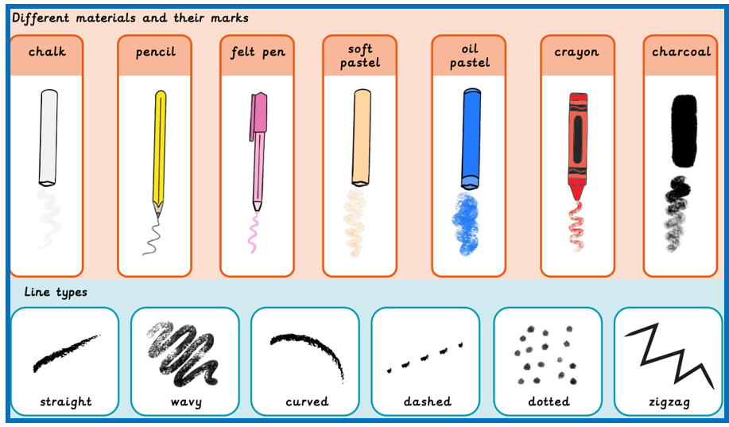

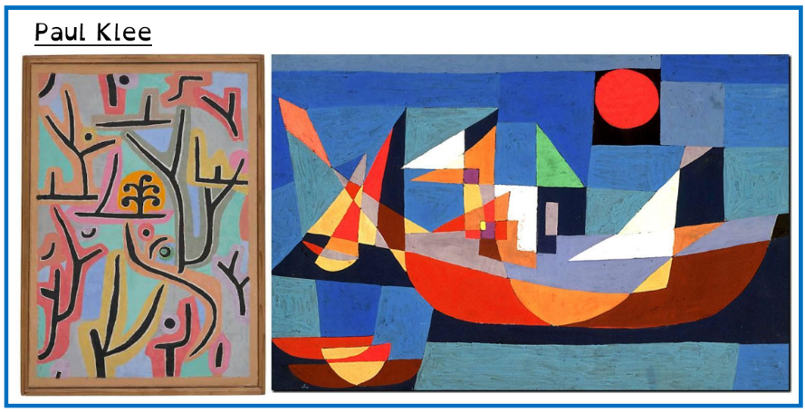

Key words


