St Joseph’s Catholic Primary School |  |  |  | Knowledge Organiser |  |  | 
Foundation in Art  Year 2 |  | Autumn  Drawing: Understanding tone and texture
Lesson 1  Creative Journey  To investigate maps as a stimulus for drawing | Lesson 2  Relief Maps  To develop a drawing into a 3D artwork |  | Lesson 3  Abstract Maps  To experiment with a craft technique to develop an idea |  | Lesson 4  Print Possibilities  To develop ideas and apply craft skills when printmaking | Lesson 5  Gallery experience  To present artwork and evaluate it against a design brief
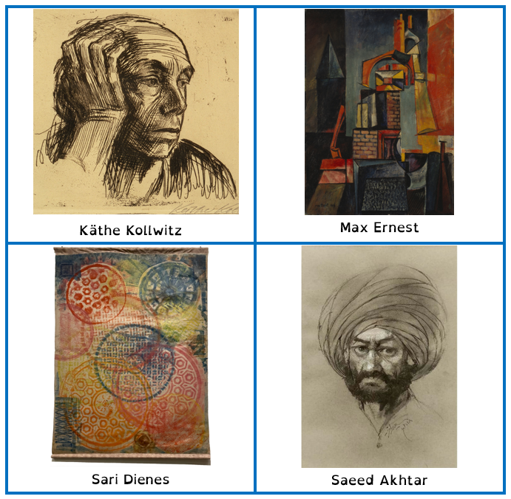
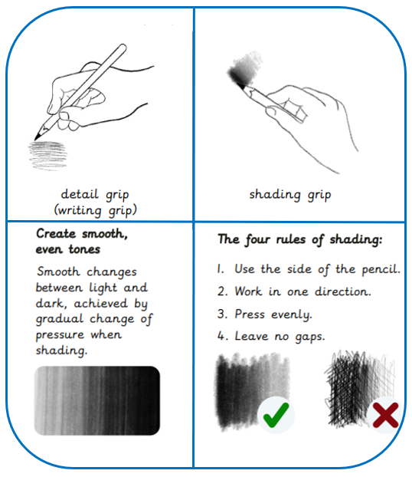
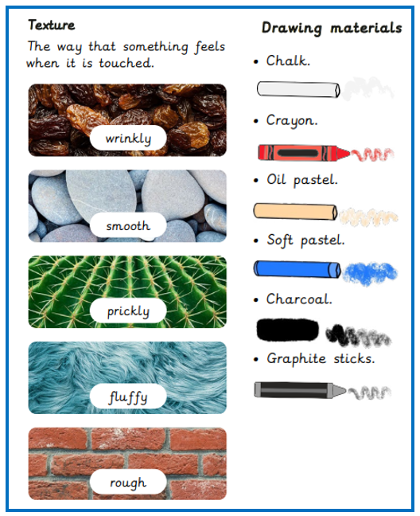
How to shade Artists Texture and Drawing materials
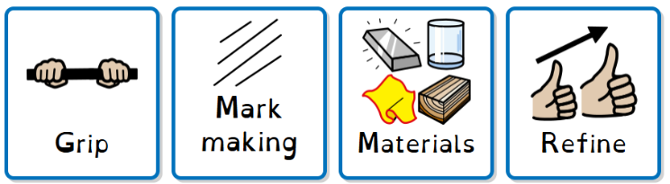
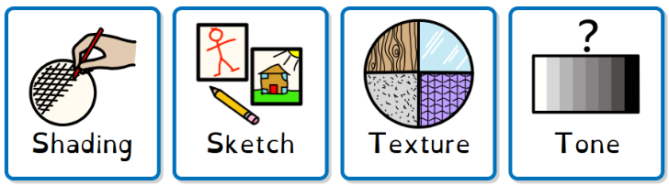
Key words

