St Joseph’s Catholic Primary School |  |  |  |  | Knowledge Organiser |  | 
Foundation in Art  Year 4 |  |  | Autumn  Drawing: Exploring Tone, Texture and Proportion
Lesson 1  3D pencil drawings  To draw using tone to create a 3D effect |  | Lesson 2  Texture and tone  To explore how combining lines and mark making can show texture and tone in drawings |  | Lesson 3  Understanding proportion  To understand proportion by observing how it is used in artwork |  | Lesson 4  Creating an effective composition  To understand what is an effective composition in art | Lesson 5  Using texture, tone and proportion in drawing  To apply an understanding of texture, tone and proportion in drawing
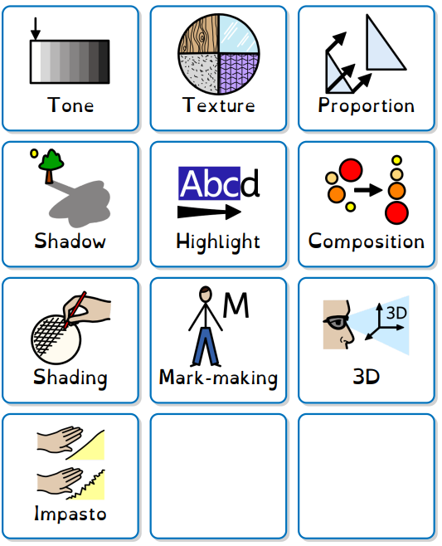
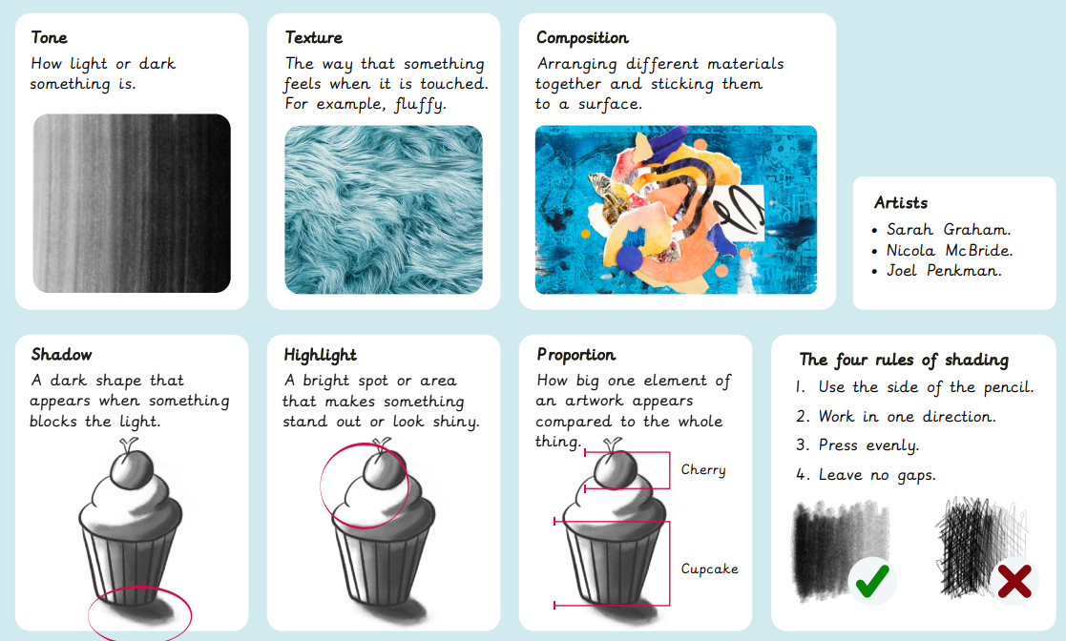
Key words

