St Joseph’s Catholic Primary School |  |  |  |  | Knowledge Organiser |  |  | 
Foundation in Art  Year 5 |  |  | Autumn  Sculpture: Interactive installation
Lesson 1:  What is installation art?  To identify and compare features of art installations. |  | Lesson 2:  Space and scale  To investigate the effect of space and scale when creating 3D art. |  | Lesson 3:  Everyday amazing  To problem-solve when constructing 3D artworks. |  | Lesson 4:  Creative concepts  To plan an installation that communicates an idea. | Lesson 5:  Viewer experience  To apply their knowledge of installation art and develop ideas into a finished piece.
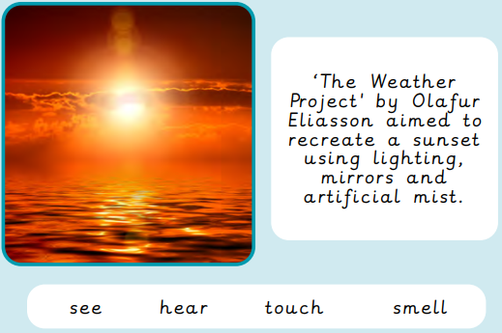
Installation Art Interactive art
3D art that aimsn to transform a space
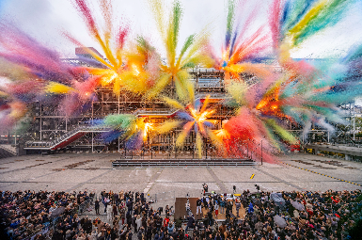

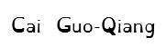
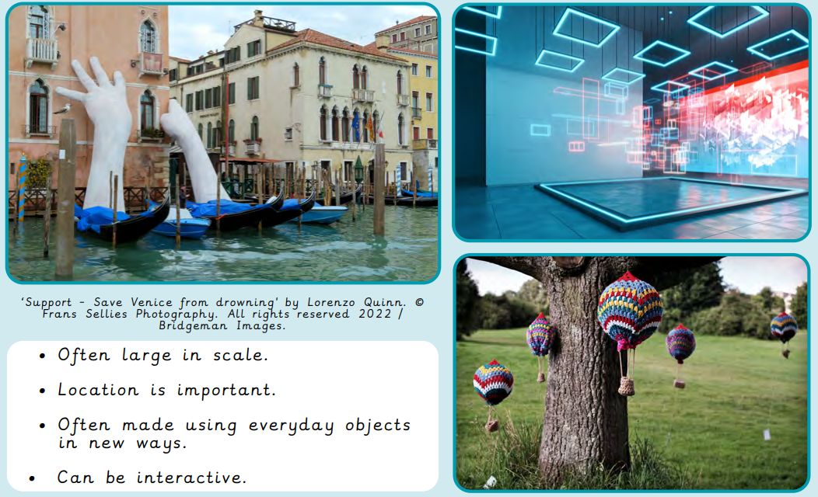
Key words


