St Joseph’s Catholic Primary School |  |  |  | Knowledge Organiser |  |  |  | 
Foundation in DT  Year 2 |  | Autumn  Cooking and Nutrition: Eating Seasonally
Lesson 1  Food around the world  To explain why food comes from different places around the world | Lesson 2  Seasonal food  To explain the benefits of seasonal food |  | Lesson 3  Cutting and peeling  To develop cutting and peeling skills |  | Lesson 4  Tasting seasonal ingredients  To evaluate seasonal ingredients | Lesson 5  Making a mock-up  To design a mock-up using design criteria | Lesson 6  Evaluating seasonal tarts  To evaluate a dish
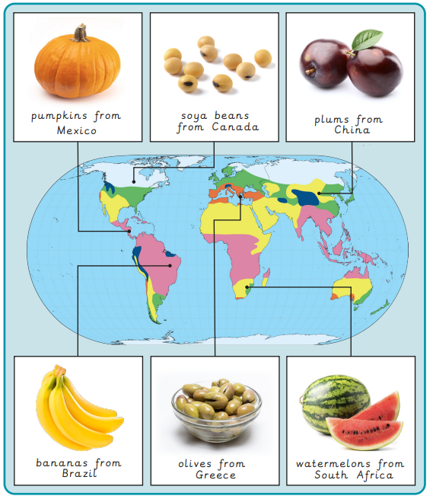
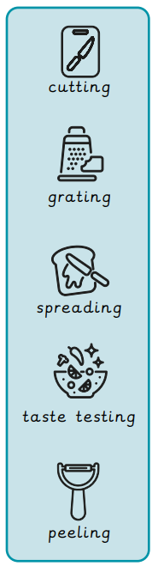
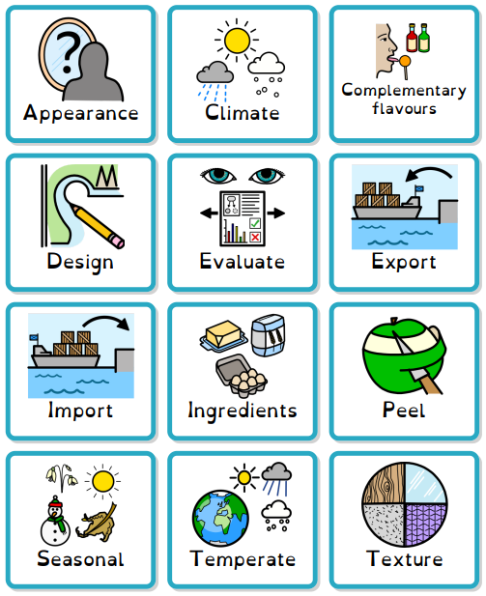
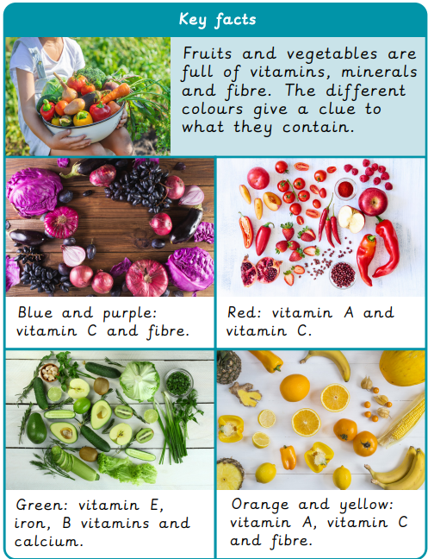
Key facts Food from around the world Skills Key Words

