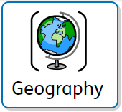

What we are learning
Lesson 1: Develop an enquiry question | Lesson 2: Creating data collection methods | Lesson 3: Mapping the route | Lesson 4: Collecting the data  Year 6: Can I carry out an independent fieldwork enquiry? | Lesson 5: Analysing the data | Lesson 6: Presenting the data



