
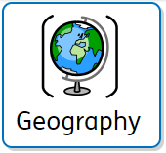
Why do people live near volcanoes?

What we are learning
Lesson 1: How is the Earth constructed? | Lesson 2: Where are mountains found? | Lesson 3: Why and where do we get volcanoes? | Lesson 4: What are the effects of a volcanic eruption? | Lesson 5: What are earthquakes and where do we get them? | Lesson 6: Where have the rocks around school come from?

Key vocabulary
Active volcano | A volcano currently erupting or is likely to erupt soon. | 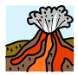
Dormant volcano | A volcano that may erupt again but has not erupted for a while. | 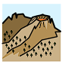
Extinct volcano | A volcano that has not erupted in 10,000 years and is not expected to erupt again. | 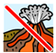
Composite volcano | A large cone shaped volcano built up by many layers of hardened lava and tephra (rock particles ejected by a volcanic eruption). | 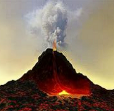
Earthquake | A shaking of the ground caused by tectonic plates moving. | 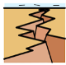
Metamorphic rock | When rock started out as a different kind of rock and was transformed with heat or pressure. | 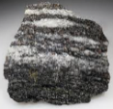
Igneous rock | Formed from the cooling of melted rock (either lava or magma) into solid form. | 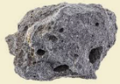
Magma | Molten, or hot liquefied, rock located deep below the Earth's surface. | 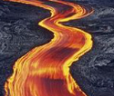
Epicentre | The part of the earth's surface directly above the starting point of an earthquake. | 

