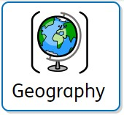
 Year 4
Why are rainforests important to us?
Key vocabulary
Biome | A geographical area with specific climate, vegetation and animal life. | 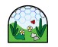
Buttress roots | Large, wide roots on all sides of a shallowly rooted tree | 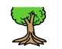
Global warming | A gradual increase in the earth's temperature | 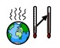
Greenhouse gases | Gases in the earth's atmosphere that trap heat | 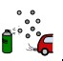
Vegetation | All plants and trees | 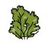
Deforestation | The clearing or thinning of forests by humans | 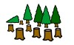
Community | A group of people who are united by something they have in common | 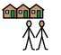
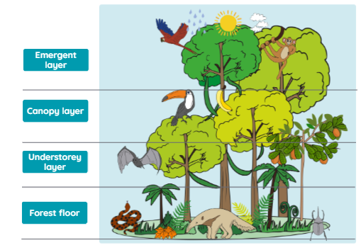
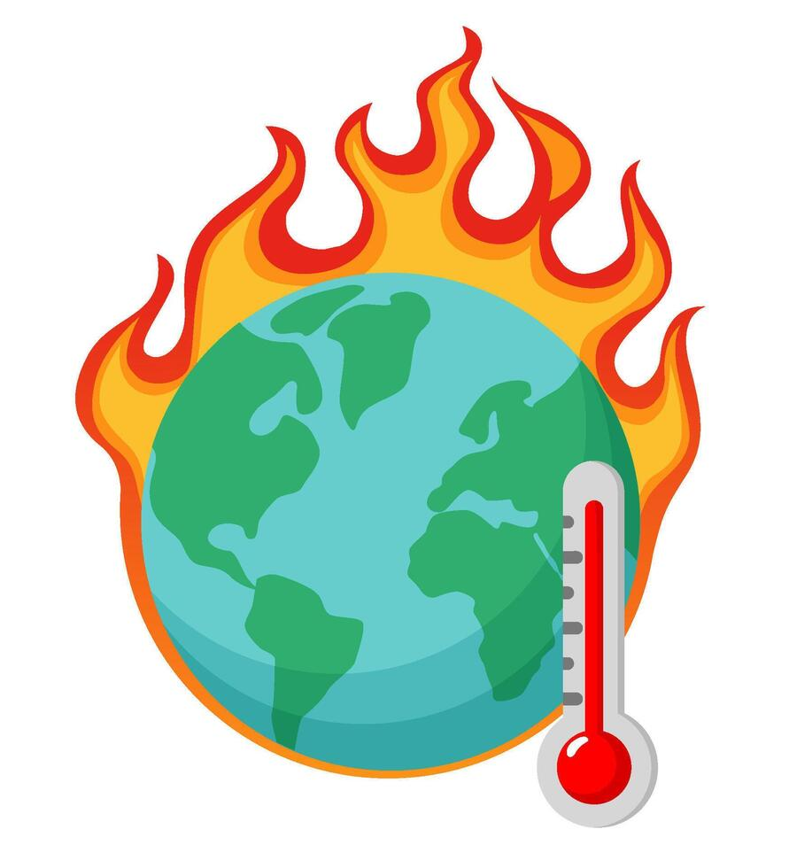
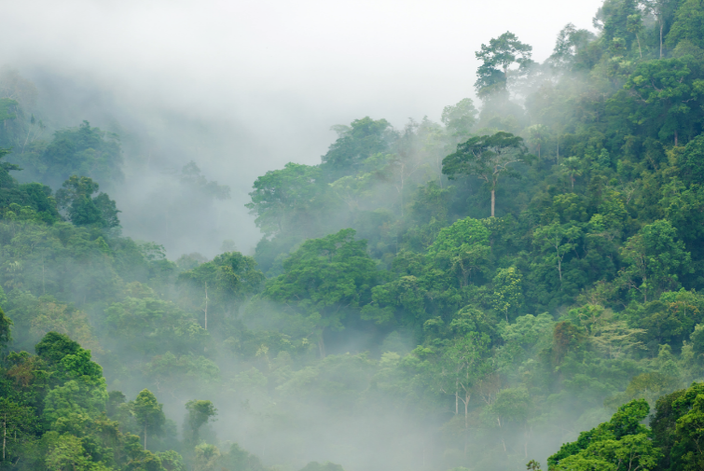
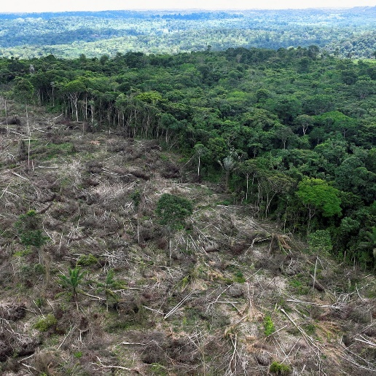
 |  | What we are learning
Lesson 1: Where in the world are tropical rainforests? | Lesson 2: What is the  Amazon rainforest like? | Lesson 3: Who lives in the rainforest? | Lesson 4: How are the rainforests changing? | Lesson 5: How is our local woodland used? (Data collection) | Lesson 6: How is our local woodland used? (Results)

