Provided by:
Croydon’s
Educational Psychology Service
Coronavirus
Support & Guidance for Parents/Carers
How to look after yourself and your children

Looking after yourself, looking after your children
Taking care of our mental health and checking in on others is something that we can all do, and we need to remember that by looking after our own mental health, we’ll be best placed to look after our children. Remember when they tell you on aeroplanes that you need to put on your own oxygen mask before helping others, it’s like that.
You don’t need to feel under pressure to recreate a school learning environment at home. The most important thing in these times of uncertainty is to spend time with your family. Cuddle up together, take turns in reading, do puzzles, build dens, bake, watch TV together, in other words don’t stress about your children not keeping up with their schoolwork. Your children will not learn much if they are stressed.
Although this is a scary time it could very well be a time that they remember as the best time in their life through spending precious time with family members.

Here are our top tips:

- Talk to your children and answer their questions. Ask about what they have heard about the virus and the situation so that you can correct possible misconceptions and reassure them.

- Avoid being too immersed in media coverage. Be mindful of the amount of things you are reading and watching, including social media – as this may add to worry and anxiety. Consider a few updates every day from trusted sources.

- Remember that people react differently to significant events. Some people – adults and children – may feel worried, some excited, some nothing much at all. Be reassured that different reactions are normal and ok.

- If your child seems worried, it may be good to distract themselves with something that takes their mind off their worries. You might also want to set aside 10-15 minutes each day for them to talk about any worries, and to reassure them.

- Remember to keep things positive and give children hope. For example, tell children that now many people are working to make this better and that even though it is serious, everyone is doing their best to help people.

- Try to keep familiar routines. Well-known routines in everyday life provide security and stability.

- Do nice things together, and keep active. Make a plan and suggest some regular family times where you can play games, do some exercise together, or do other things that you know most of you like. Try to find a good balance between times together, and screen time.

- Keep in good contact with family and friends (via Facetime, Skype WhatsApp etc.; following NHS guidance on ‘social contact’). This will help children connect with others and know that others are thinking about them. It will also reassure them that others are well.

- As a parent you may be concerned yourself. Take care of yourself and make sure you have breaks, time to relax, and ask for help from others if you need.

Here are some useful links:

- Talking to children about Coronavirus
There is currently a lot of uncertainty and worry around the coronavirus outbreak and children and young people will be affected by the huge changes that are going on around them - regardless of their age or any additional needs. It is really important that adults explain what is happening to children and young people in an age appropriate way so they understand what is happening. Some useful links are:
Talking to children about Coronavirus (British Psychological Society): https://www.bps.org.uk/news-and-policy/talking-children-about-coronavirus
Talking to Children (Childmind): https://childmind.org/article/talking-to-kids-about-the-coronavirus/
How to talk to your child about coronavirus (Unicef): https://www.unicef.org/coronavirus/how-talk-your-child-about-coronavirus-covid-19
Tips and guidance on supporting preschool children (Zero to Three); https://www.zerotothree.org/resources/3210-tips-for-families-coronavirus
Talking to children (National Association of School Psychologists)
https://www.nasponline.org/resources-and-publications/resources-and-podcasts/school-climate-safety-and-crisis/health-crisis-resources/talking-to-children-about-covid-19-(coronavirus)-a-parent-resource

- Stories about Coronavirus for children
Visual stories are a useful way of helping children to understand the Coronavirus. Here are some links to some good examples:
ELSA: Coronavirus Story for Children: https://www.elsa-support.co.uk/coronavirus-story-for-children/
Hello! Story about Coronavirus for young children:https://660919d3-b85b-43c3-a3ad-3de6a9d37099.filesusr.com/ugd/64c685_319c5acf38d34604b537ac9fae37fc80.pdf
A comic exploring coronavirus to help young people understand: https://www.npr.org/sections/goatsandsoda/2020/02/28/809580453/just-for-kids-a-comic-exploring-the-new-coronavirus?t=1584464333506
Covibook – an interactive resource designed to support and reassure children aged 7 and under, designed to help children explain and draw the emotions that they might be experiencing during the pandemic: https://www.mindheart.co/descargables

- Information Videos for children about the Coronavirus

Information video on Coronavirus for Primary age children (KS2) (Brainpop):
https://www.brainpop.com/health/diseasesinjuriesandconditions/coronavirus/

Information video on Coronavirus for older children/adults (WHO):
https://www.youtube.com/watch?v=mOV1aBVYKGA&feature=youtu.be

- Promoting Children’s Wellbeing

Advice for young people who are feeling anxious about Coronavirus (Young Minds):
https://youngminds.org.uk/blog/what-to-do-if-you-re-anxious-about-coronavirus
Helping children cope with stress (WHO):
https://www.who.int/docs/default-source/coronaviruse/helping-children-cope-with-stress-print.pdf?sfvrsn=f3a063ff_2
Advice for older pupils and adults about looking after their emotional well-being. https://afsp.org/taking-care-of-your-mental-health-in-the-face-of-uncertainty/?fbclid=IwAR3ScDBfuhV5INKyutAG9IPNm4JnjjLOmHxv5w8SR9pBbDDU-8Hhy1QH-L8

- Mindfulness for Children

At 2pm, there are free on-line mindfulness group sessions for kids from Mindful Schools: https://www.mindfulschools.org/free-online-mindfulness-class-for-kids/?utm_source=Mindful+Schools+Newsletter&utm_campaign=7968a81a59-EMAIL_CAMPAIGN_NEWSLETTER_2020_03_18_NONREG&utm_medium=email&utm_term=0_024a46d2a1-7968a81a59-20835055
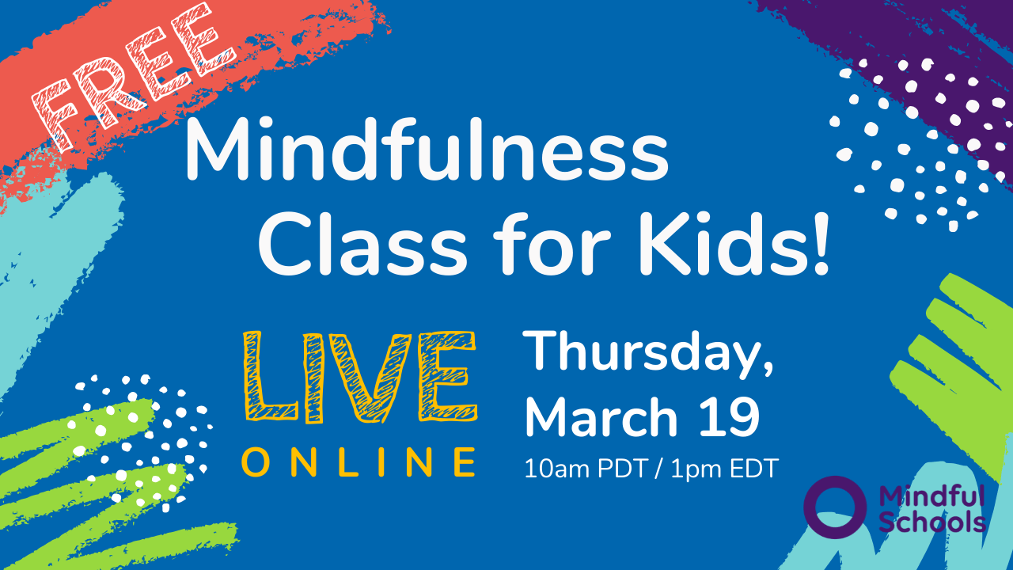 | Free: Online Mindfulness Class for Kids! - Mindful Schools  For the next few weeks, Mindful Schools will be offering free mindfulness classes for kids! Join us online – for mindful activities, mindful movement, read-alouds – and let’s have fun exploring mindfulness together.  www.mindfulschools.org
Smiling Mind <https://www.smilingmind.com.au/> - Smiling Mind is a great mindfulness app/website for the whole family (Age 7+).
Cosmic Kids <https://www.youtube.com/user/CosmicKidsYoga> - Yoga and mindfulness for kids ages 3+.

- Special Needs and the Coronavirus

Parent-focused ideas from Special Needs Jungle about how to support children with anxiety around coronavirus, including an easy-read explanation for children and adults with learning difficulties: https://www.specialneedsjungle.com/calming-coronavirus-anxiety-children-everyone-else/#Update

Autism and the Coronavirus: top tips
https://petervermeulenblog.wordpress.com/2020/03/16/autism-and-the-corona-virus-20-tips/

A social story about pandemics (Carol Gray): https://carolgraysocialstories.com/wp-content/uploads/2020/03/Pandemics-and-the-Coronavirus.pdf?fbclid=IwAR23zxNlbEumpw4oKlM7Xy3VlKnA25b8Gi53N6YiFIeKB9Vx0LQypSPYzzg
A Social Story about the coronavirus: https://www.ppmd.org/wp-content/uploads/2020/03/The-Corona-Virus-Free-Printable-Updated-2-The-Autism-Educator-.pdf
See the example social story on the last page

- Looking after your own wellbeing

How to protect your mental health (BBC): https://www.bbc.co.uk/news/health-51873799
Coronavirus and your wellbeing (Mind UK):https://www.mind.org.uk/information-support/coronavirus-and-your-wellbeing/
5 ways to wellbeing (Mindkit):https://www.mindkit.org.uk/5-ways-to-wellbeing/

- Health Advice

NHS advice: https://www.nhs.uk/conditions/coronavirus-covid-19/
Public Health England have produced an easy read version of their Advice on the coronavirus for places of education. You can download it here.

Local Information

Croydon Local Offer
https://localoffer.croydon.gov.uk/kb5/croydon/directory/home.page
The Local Offer provides information and advice about services that children, young people and their families can expect from a range of local agencies. It also provides information on a wide range of activities to do in and around Croydon.

Croydon Voluntary Action
https://cvalive.org.uk/coronavirus/
CVA is mapping the services still being run and the new activities being set up to support people in need.

Croydon Library 24/7 online services
https://www.croydon.gov.uk/leisure/libraries/online-library/247-online-services
A range of online resources are part of the Library Service’s information and learning offer.

Croydon Educational Psychology Service Twitter
https://twitter.com/CroydonEps
Hardworking and hopeful EPs trying to ensure positive outcomes for children/young people in Croydon.

20th March 2020

General sources of support
For parents
Samaritans
Call 116 123
https://www.samaritans.org/how-we-can-help/contact-samaritan/

Mind UK
https://www.mind.org.uk/
https://www.mind.org.uk/information-support/support-community-elefriends/
UK Mental Health Charity with information and an online mutual support community

For young people
www.kooth.com
www.youngminds.org.uk
www.keep-your-head.com

Parenting pressures

Family Action
Telephone: 0808 802 6666
Text message: 07537 404 282
https://www.family-action.org.uk/what-we-do/children-families/familyline/
The FamilyLine service supports people who are dealing with family pressures in a new and innovative way by using a network of volunteers from across the country to support family members over the age of 18 through telephone calls, email, web chat and text message.

Family Lives (previously Parentline)
Call: 0808 800 2222
https://www.familylives.org.uk/how-we-can-help/confidential-helpline/
Family Lives offers a confidential and free helpline service for families in England and Wales (previously known as Parentline). for emotional support, information, advice and guidance on any aspect of parenting and family life. The helpline service is open 9am – 9pm, Monday to Friday and 10am – 3pm Saturday and Sunday.

Gingerbread
Single Parent Helpline: 0808 802 0925
Https://gingerbread.org.uk
One Parent Families/Gingerbread is the leading national charity working to help lone parents and their children.

Grandparents Plus
Call: 0300 123 7015
https://www.grandparentsplus.org.uk/
Grandparents Plus is the only national charity (England and Wales) dedicated to supporting kinship carers - grandparents and other relatives raising children who aren't able to live with their parents

A Social Story about Coronavirus
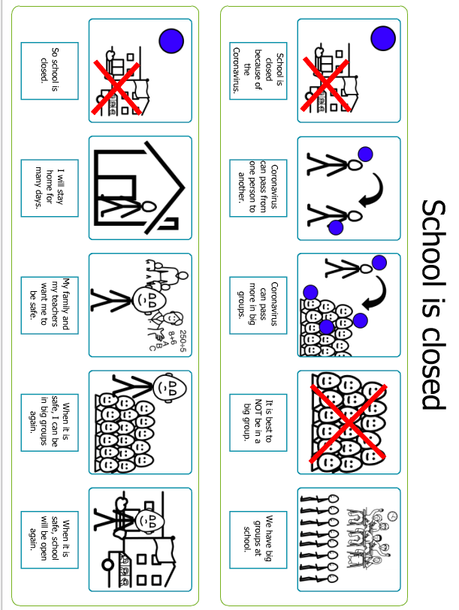
(Acknowledgement to Southend Educational Psychology Service)

